University of Technology, Jamaica
School of Computing and Information Technology CNS3005: Ethical Hacking
Lecturer: Kevin Johnson Mekhi Bentley (2304855)
Lab 5

Performing an nmap service scan

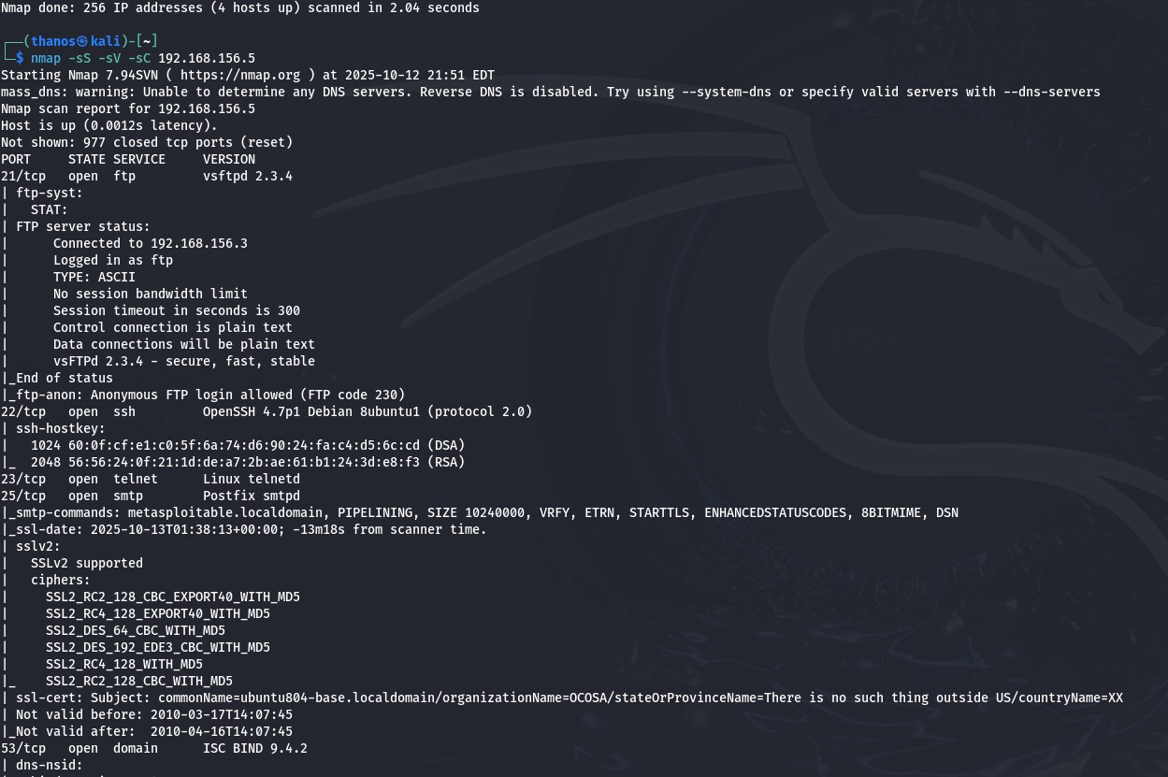
Using nmap to identify open ports, service versions, and other useful information that we can use to gain access to the target machine.

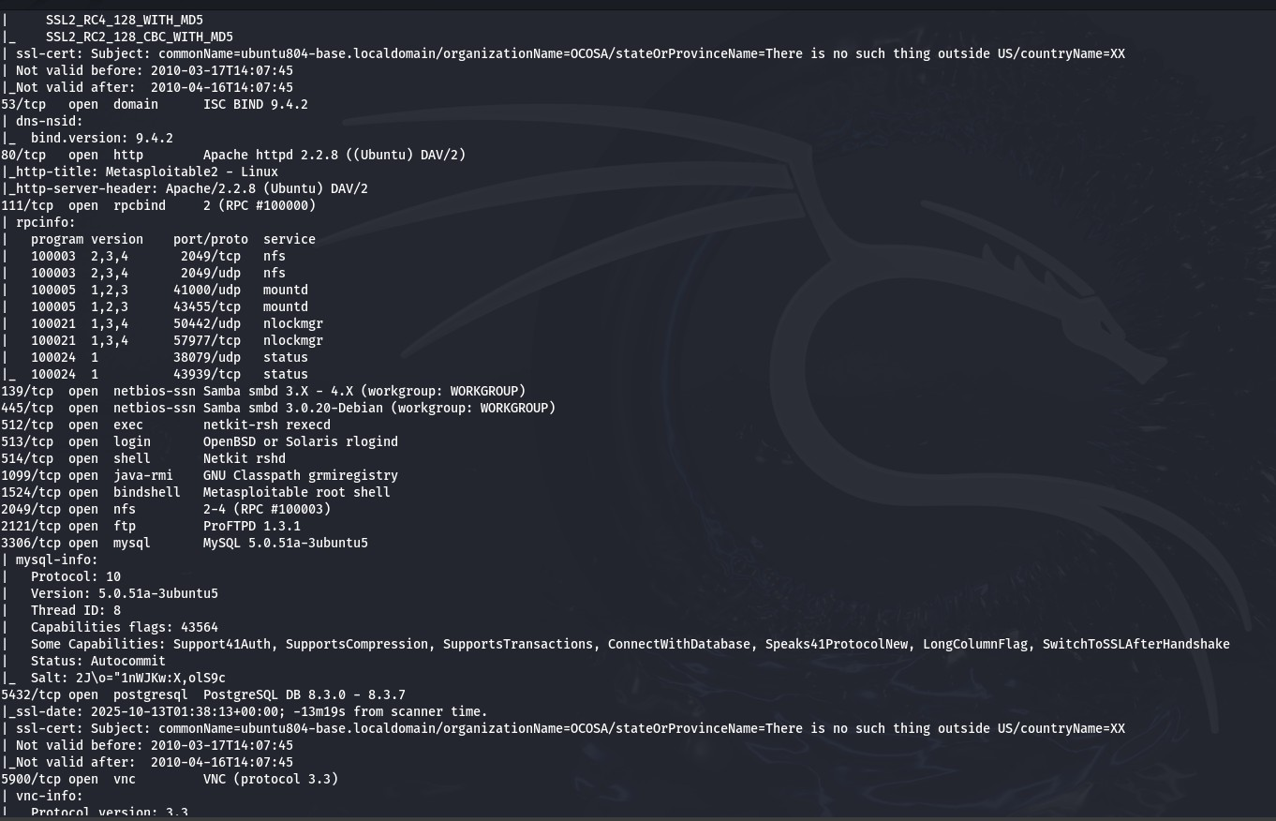

Exploiting FTP

- Using hydra to brute-force the Metasploitable 2 vm’s ftp service
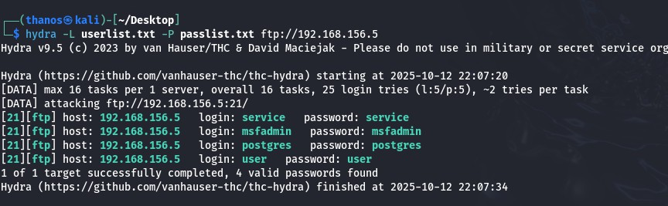

- Accessing Metasploit2’s FTP services using cracked credentials
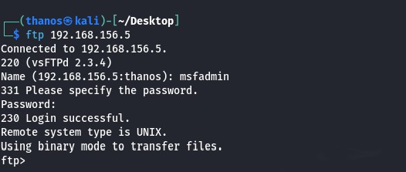

- List files stored on the target’s FTP server
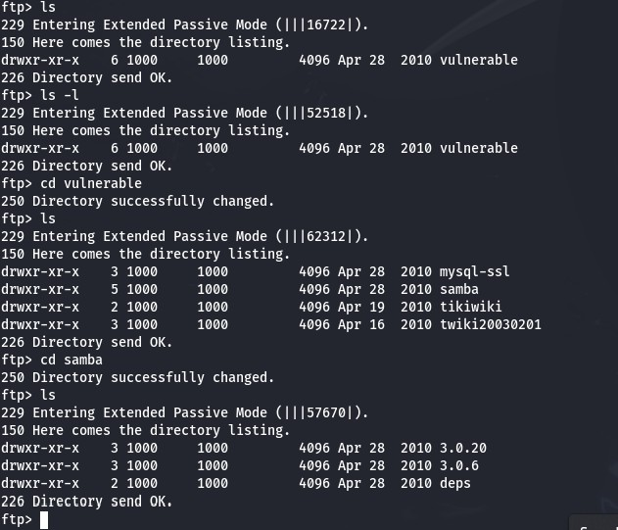

- Exfiltrating files from the ftp server to my local virtual machine
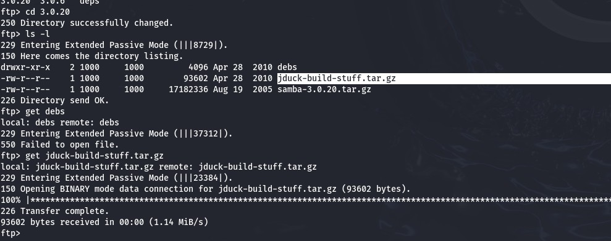

Exploiting VSFTPD 2.3.4

- Searching for vsftp exploits using searchsploit and metasploit
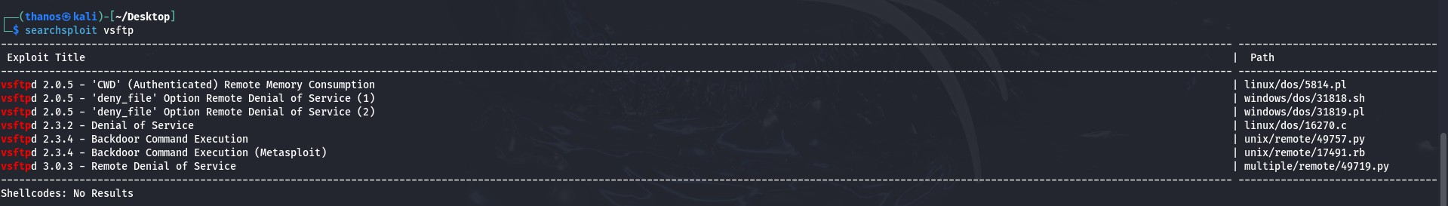
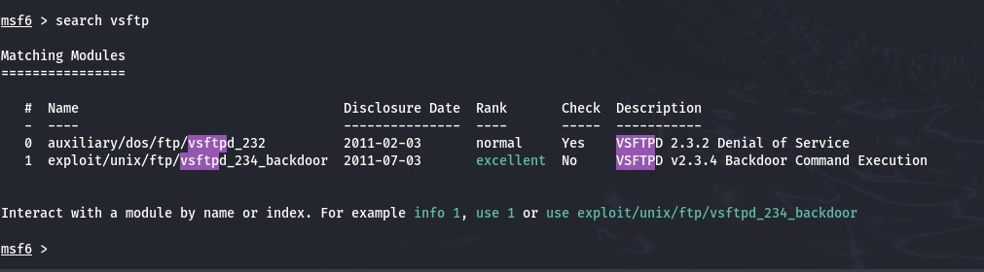

- Setting RHOST option to the target’s ip address
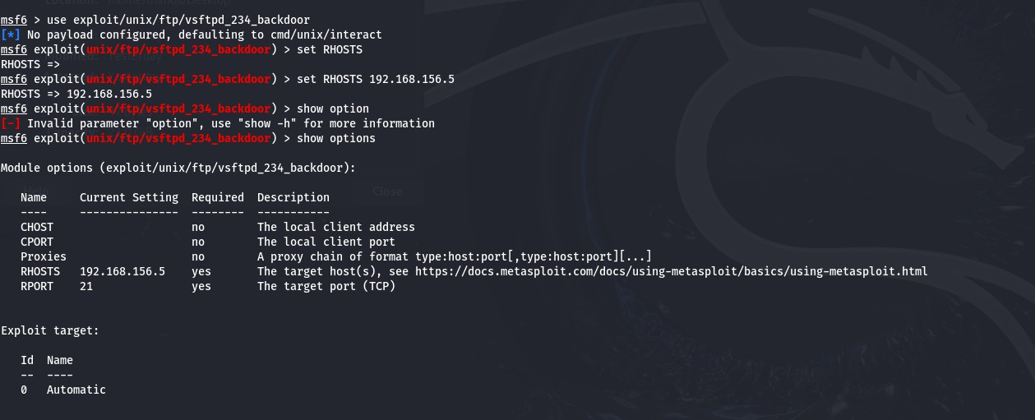

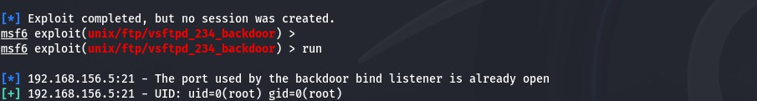
- Running the exploit using metasploit to access the target through its vsftp's 2.3.4 backdoor.

- successfully infiltrated the Metasploitable 2 virtual machine.
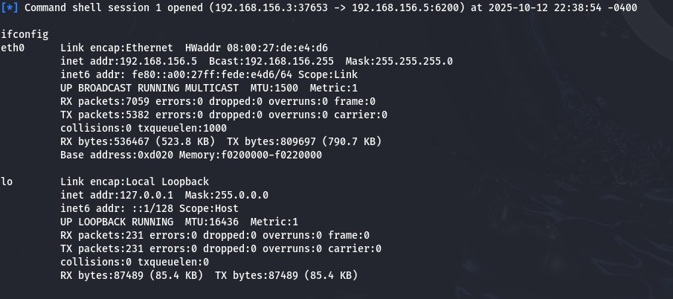
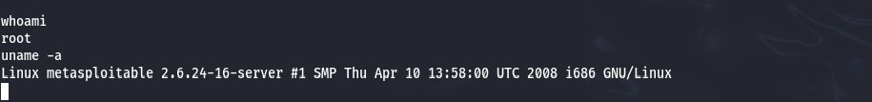

- Using searchsploit to download the exploit for vsftp 2.3.4
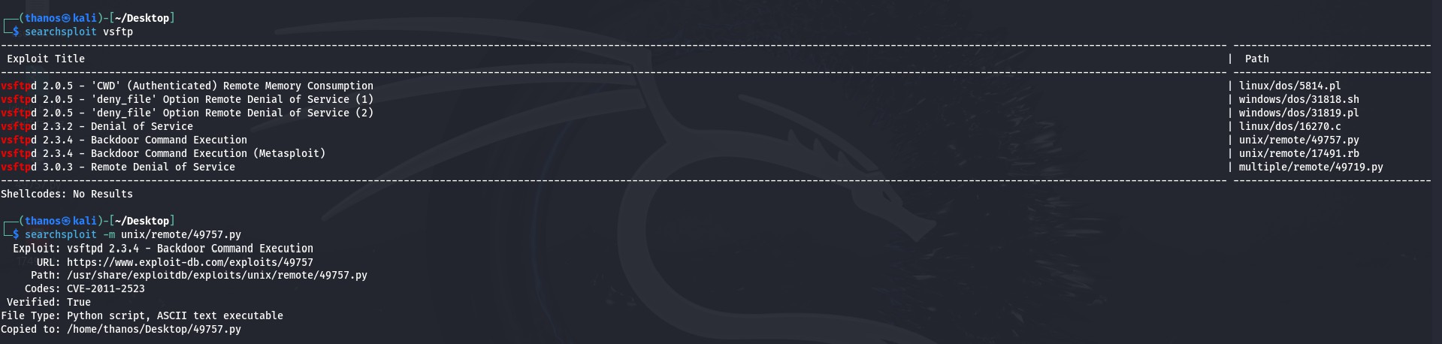

- Running the exploit using python
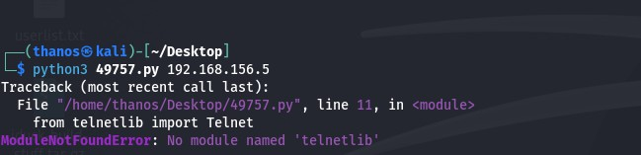

Exploiting VNC

- Using Metasploit to look for VNC exploits
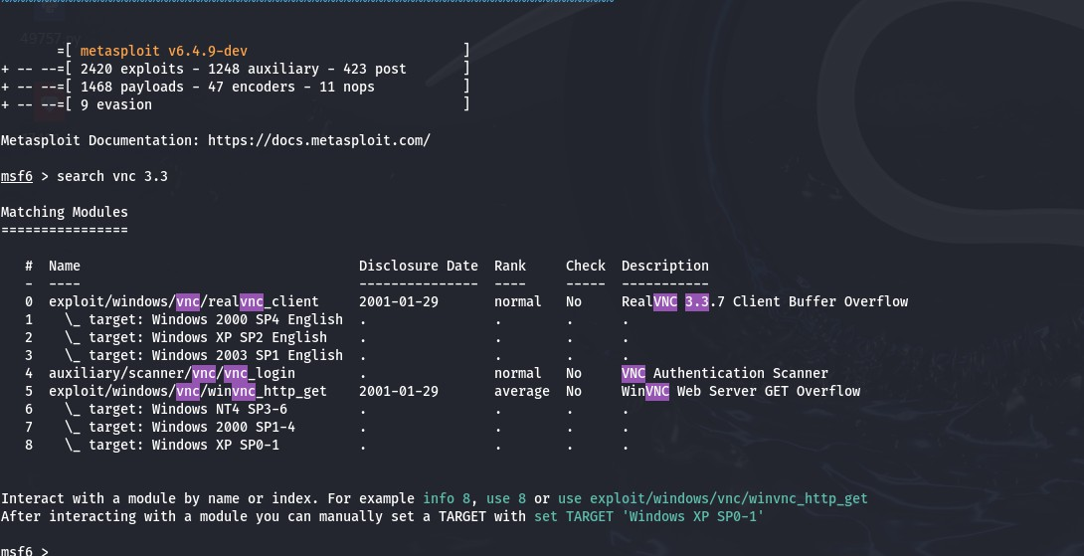

- Setting RHOST option to the target’s ip address
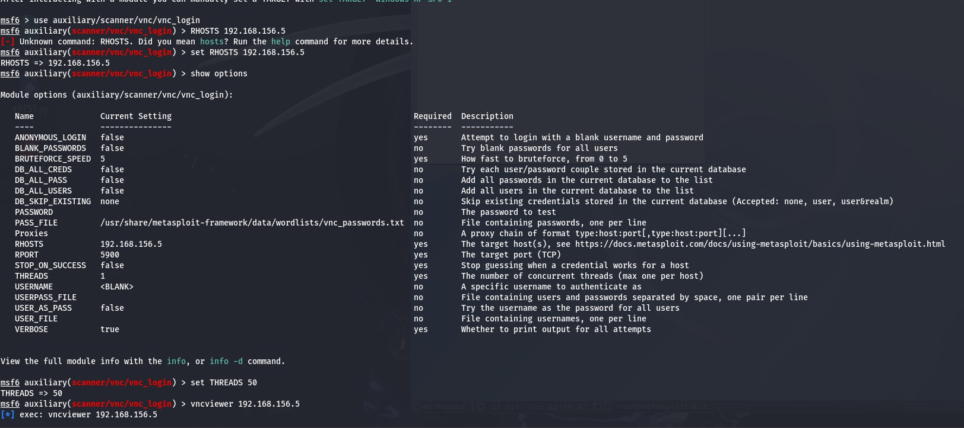

- Using the exploit to access the target machine by brute-forcing the vnc service
